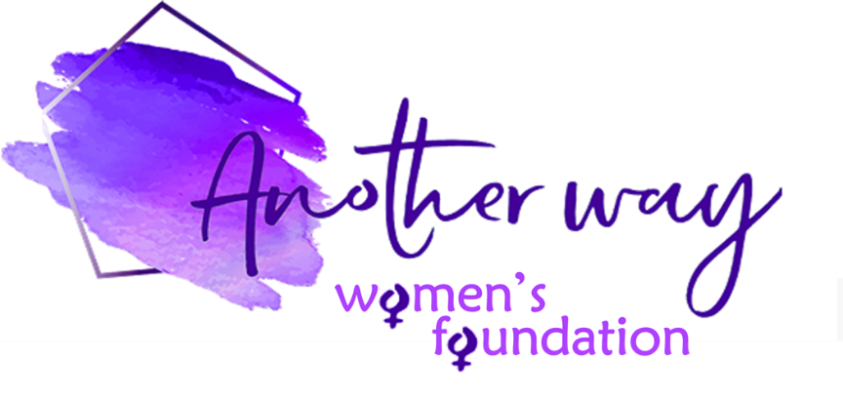

**Another Way Women’s Foundation £1000 for 1000 Words Grant – Application Form**

Thank you for applying for a £1000 grant.   
All applications must be in line with and supportive of our charitable purpose – which is   
*to enable a brighter and fairer future for women and girls through financial support, education, empowerment and advancement, and to accelerate gender equality, effect system change and advance women’s lives, sustainably, at both an individual and community level* – as well as our values and ethos – which are *to be empowering & enabling, community- and people-centric, passionate & inspiring, and trusted & respectful.*

To enable us to consider your application you must fully complete the application form, giving clear and specific responses to ALL of the questions. Without all the information we will not be able to consider your application. Your application should be NO MORE THAN 1000 WORDS.

|  |  |
| --- | --- |
| Name of organisation: | Address of organisation: |
| Registered charity number (if applicable): | Address or location of project:  (if different from above) |
| Contact name/s: | Contact phone/s:  Contact email: |
| Organisation website/social media links, if you have them: | |

|  |  |
| --- | --- |
| Please tell us about **YOUR ORGANISATION** – you must include ALL the following information:  (i) What is your charitable purpose, what services do you provide, and to whom? (*200 words MAX*)  (ii) Is your organisation UK-based? YES NO  (iii) Do the values and ethos of your organisation match those of AWWF? YES NO  (iv) Approximately how many women/girls do you support each year?  (v) Do you include non-binary and transgender individuals in your classification of ‘women’?   YES NO  (vi) Is your organisation secular or affiliated to a religious organisation?  Secular Affiliated to a religious organisation  (vii) How many employees does your organisation have?  (viii) How many volunteers does your organisation have?  (ix) How many employees in your organisation earn £60,000+?  (x) What is the annual salary of the CEO (or equivalent role)? | |
| Briefly, tell us about **THE PROPOSED PROJECT AND ITS IMPACT** – you must include ALL the following information:  (i) What is the specific project and/or service(s) that you would like grant support for?  (5*00 words MAX*)  (ii) When will the project start and end?  (iii) Will the proposed project and/or service(s) be delivered in the UK? YES NO  (iv) Is the project and/or service(s) not for profit and not for self-benefit? YES NO  (v) How will the £1000 grant be spent and how do you think it will positively impact women and girls in need and/or the community? How many women/girls do you think will be impacted? Do you have a way of measuring impact and, if so, how?  (vi) What are the project objectives and are they **S**pecific, **M**easurable, **A**chievable, **R**elevant and **T**ime-based? | |
| If your application is successful, we would require you to provide a written report on project completion outlining successes versus the project objectives. Also, we require a testimonial and pictures to be provided, where possible, for us to use on our website to publicise your cause.  Please state that you agree to these conditions: YES NO  We appreciate the need for confidentiality and should you have concerns about this, please outline these below and we will ensure to take this into consideration. It should also be noted that we will always abide by all GDPR regulations. | |
| Signed on behalf of the above organisation: | Date of signature: |

**­­­­­­­­­**

While we would like to respond to all applicants in person, this might not always be possible and Another Way Women’s Foundation reserves the right to decline applications without reason.

Unsuccessful applicants may apply again – please check our website for the next deadline.

Should the projects not be completed within the outlined timeframes or metrics we reserve the right for full or partial repayment of the grant, and by submitting this application it will be assumed that you agree to this term.

**THE COMPLETED FORM SHOULD BE EMAILED TO:** [**hello@anotherwaywf.org**](mailto:hello@anotherwaywf.org)